# Introduction

A soda can is a good model of a thin walled pressure vessel. The stresses a cylindrical pressure vessel experience due pressure are hoop stress and axial stress, which are represented in the figure below.

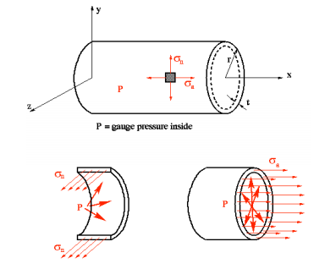Figure 1: Forces in a thin walled pressure vessel

Hoop stress is a normal stress to the circumference. Axial stress is parallel to the axis of symmetry.

In this experiment, the strain gauge will be measuring hoop strain. In order to get the stress the following equation must be used.

$ε=\frac{σ_{θ}}{E}$ (1)

Where ε is the strain, E is Young’s Modulus, and σθ is the hoop stress.

With the hoop stress, the pressure in the vessel can be found using the following equation.

$σ_{θ=\frac{Pr}{t}}$ (2)

Where P is the vessel pressure, t is the wall thickness, r is the inner radius of the vessel, and σθ is the hoop stress. The axial stress can be found using the following equation.

$σ_{z}=\frac{Pr}{2t}$ (3)